21 December, 2023

**PRESS RELEASE**

###### TOURISM STATISTICS 2020 [1] - 2022

**Travelers**

The movement of travelers to and from Cyprus in 2022 recorded an increase compared to 2021 and 2020. Total arrivals of travelers reached 4.833.939 (Figure 1) recording an increase of 85,8% and departures totaled 4.815.779, also recording an increase of 86,4%, compared to 2021. In 2020 arrivals of travelers reached 1.164.938 and departures 1.167.942.

Air traffic represented 95,5% of arrivals and 95,4% of departures in 2022.

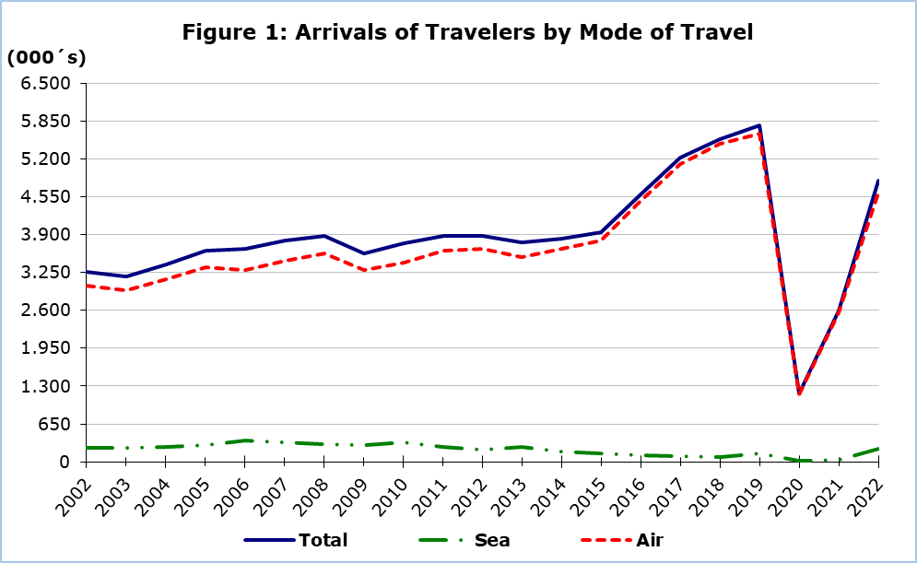

**Tourists**

Tourist arrivals increased by 65,3% and reached 3.201.080 in 2022 compared to 1.936.931 in 2021. In 2020 tourist arrivals were estimated at 631.609 (Figure 2).

During 2022, the United Kingdom was the most important source of tourism for Cyprus with a share of 37,9% of the total tourist traffic, followed by Israel with 8,7%, Germany with 6,2%, Poland with 5,8%, Greece with 5,3%, Sweden with 3,7%, Austria with 2,2% and Denmark with 2,1% (Figure 3).

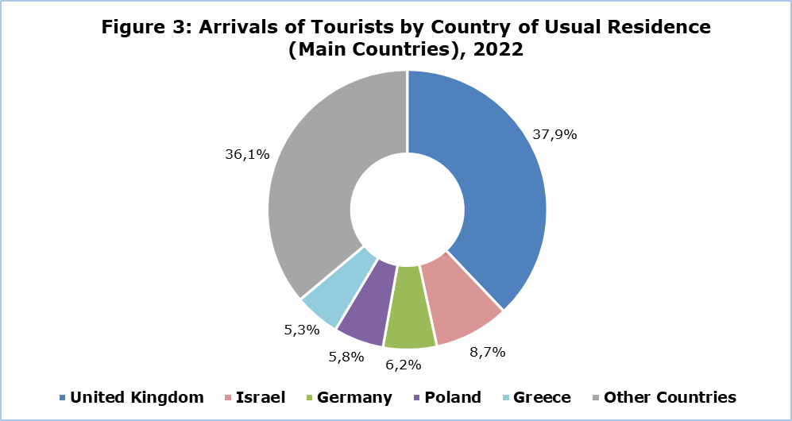

Out of the total number of tourists, 35,7% stated that they stayed in Pafos, 16,2% in Ayia Napa, 12,1% in Larnaka, 12,0% in Limassol, 11,2% in Paralimni and smaller proportions in other areas.

For a percentage of 80,8% of tourists, the purpose of their trip in 2022 was holidays, for 13,0% visit to friends and relatives and for 6,1% business.

**Revenue from Tourism**

In 2022, revenue from tourism was estimated at €2.439,2 mn, compared to €1.513,6 mn in 2021 and €392,0 mn in 2020. Tourism revenue in 2022 recorded an increase of 61,2% compared to 2021.

The average expenditure per person was €761,92 in 2022 recording a decrease of 2,5% from 2021. The highest average expenditure per person in 2022 was recorded in the month of August with €885,98 and the lowest in the month of December with €523,42 (Figure 4).

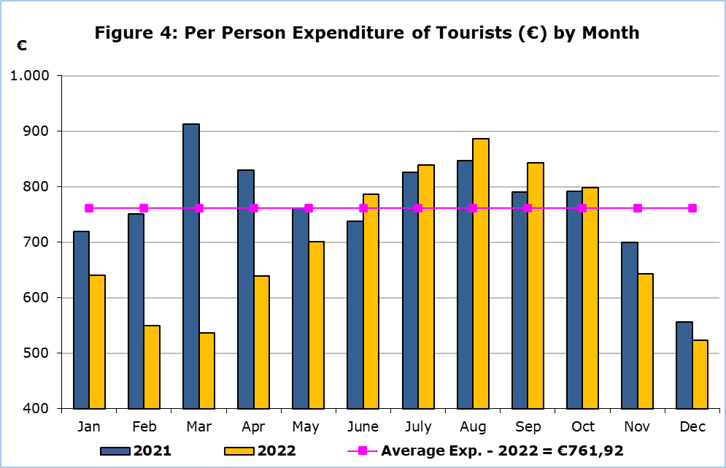

**Residents of Cyprus**

The trips of residents of Cyprus abroad increased by 145,2% in 2022, and reached 1.259.643 as compared to 513.660 in 2021 and 485.806 in 2020.

In 2022 about 36,0% visited Greece, 14,5% the United Kingdom, 4,8% Italy, 3,5% Germany, 3,1% Bulgaria and 2,7% France. The peak-season for residents traveling abroad was the period of July-September.

A percentage of 72,3% of the residents of Cyprus traveling abroad in 2022 stated that the main reason for traveling was holidays, 17,9% stated professional reasons, 7,0% studies and 2,8% other purposes.

**METHODOLOGICAL NOTES**

**Definitions**

**Travelers -** Are all persons who pass through passport control at the ports and airports of Cyprus. The various categories of travelers are visitors, residents and emigrants or immigrants.

**Tourists** - Are visitors staying at least one night in the country visited.

**Revenue from Tourism -** It refers to the revenue from tourists during their visit to Cyprus.

**Residents of Cyprus -** This category includes persons who have resided in Cyprus for at least 12 months prior to their travel.

**Source of Data and Coverage**

The data are obtained from the Passengers Survey which is carried out at the points of arrival in Larnaka and Pafos airports. Additionally, data are also collected from administrative sources, such as the monthly arrivals from ports.

The data covers all persons who pass through passport control at the ports and airports in the Government controlled area of Cyprus. It does not include travelers who arrive and depart illegally via ports and airports in the occupied part of Cyprus.

The weighting is conducted based on the data sent to the Statistical Service by the Civil Aviation Department and from the ship manifests, as well as on the data sent by the Analysis and Statistics Office of the Cyprus Police.

During the period of June 2020 – April 2022, the Passengers Survey at Arrivals was temporarily discontinued and the data were obtained from the electronic platform “Cyprus Flight Pass”.

***For more information:***

CYSTAT Portal, subtheme [Tourism](https://www.cystat.gov.cy/en/SubthemeStatistics?s=51)

[Predefined Tables](https://www.cystat.gov.cy/en/KeyFiguresList?s=51) (Excel)

[Publications](https://www.cystat.gov.cy/en/PublicationList?s=51)

[Methodological Information](https://www.cystat.gov.cy/en/MethodologicalDetails?m=2172)

*Contact*

Lucy Panayidou: Tel.:+35722602152, E-mail: [lpanagidou@cystat.mof.gov.cy](mailto:lpanagidou@cystat.mof.gov.cy)

1. Following the decrees issued by the Government of Cyprus and the measures taken to prevent the spread of the coronavirus pandemic (COVID-19), a ban of entry to Cyprus was imposed on several categories of persons, including tourists, for the period 15/3-8/6/2020. As of 9/6/2020, a gradual easing of the travel restrictions to Cyprus was implemented, allowing arrivals from specific countries, according to the epidemiological risk categorisation issued by the Ministry of Health. As of 18 April 2022, passengers were allowed to enter the Republic of Cyprus from any country of departure.